VR LAB Manual

Contents

Introduction to VR 3

VR Definition 3

Displays | CAVE and HMDs 5

Which VR device to use 7

LAB Devices in details 8

HTC Vive 8

CAVE 8

# Introduction to VR

## VR Definition

Virtual reality (VR) used to describe anything that happens in virtual world this includes everything (Games, Films, Ads).

Later VR started to define Immersive experiences for relatively small range of VR Displays.

* CAVE System
* OCULUS Head Rift
* HTC Vive

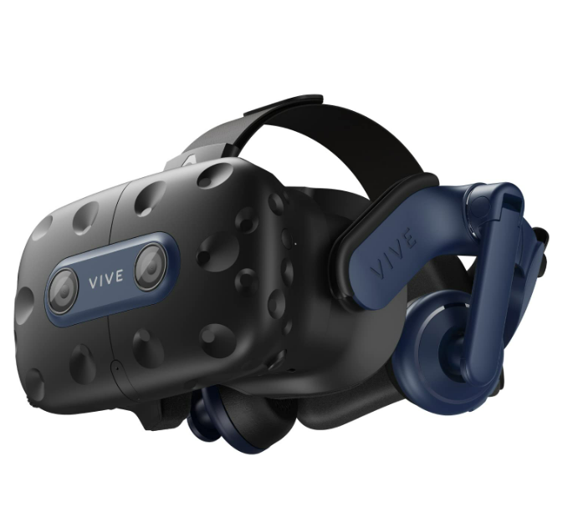

# VR Definition

A definition of VR was developed by brooks in 1999:

**User effectively immersed in a responsive virtual world.**

What mainly distinguishes VR from other media such as TV, Cinema, 3D TV, 3D Cinema :

* 3D Stereovision -you have 2 images, one for each eye (this means that you can see depth of an image ! )
* User dynamic control of viewpoint (you can control your viewpoint and display is updated according to your viewpoint)
* Surrounding experience (there is no escape, you are trapped by the virtual world)

## Displays | CAVE and HMDs

Different tools can be used to immerse user in virtual world will show some of them below.

CAVE Is acronym for cave automatic virtual environment

* Projectors with high resolution are used to surround the user with virtual environment.
* To reach 3D stereovision illusion shutter glasses are used (Active 3D).
* User dynamic control of glasses updates the display in real time.
* Hint : the dynamic control can only be done with one control of viewpoint for other users of the cave the view will be distorted.
* Designed to be used by one user at a time, used in research labs in academia and industry.

**Head Tracking**

* Head tracking is needed to update the display according to the user viewpoint.
* Tracking latency normally in the order of single digit milliseconds (not noticeable in most cases ) – time delay between user changing his viewpoint and updating display.
* The tracker is responsible for tracking both rotation and position (for CAVE System).
* These trackers can be found in smart phones for simple tracking.
* HMD (head mount display) head tracking relies on built in accelerometer and gyrometers to track users head rotation and external optical devices.
* External infrared sensors to track the position ! (range of capturing depends on the setup).
* You can still navigate the virtual world with touchpad or joystick.
* Interpreting location and updating the graphics in real time will consume a lot of computational power, that’s why we need a dedicated PC.
* Self-tracking (Inside out tracking) is a new technology that allow you to track your position without external sensor (this technology is currently under development).

**Controllers**

* In Cave often referred as WAND
* You will be interacting with object using WAND and you should be able to move object using WAND which means that you will need position and rotation tracking.
* WAND => have builtin track rotation, external optical sensors to track position.
* WAND can be used to move around in virtual world !
* Most VR controllers also can offer haptic feedback.
* Using 2D user interface with HMD may cause nausea.
* Mobile HMD come with a Mobile controller.

## Which VR device to use

There are multiple criteria to consider when developing a VR application.

* If you are willing to develop application for Mass users (everyone can use your application) you should consider using mobile application
* Developing high end application will require and HMD user hint : by the time of writing this manual the number of HMDs around world 100,200 device.
* For one user applications such as Theraby, training and simulation solutions 🡪 CAVE solution should be considered.

## LAB Devices in details

### HTC Vive

### CAVE

## History of VR

### VR in analogue age: creative arts

A painting technique, called trompe l’oeil, was very popular during the 1600s and 1700s. Trompe l’oeil is French for "deceive the eye," which artists used to create paintings that tricked viewers into believing they were seeing real objects, even though they were just paintings.

One example of trompe l'oeil is a painting that makes it look like there's a violin hanging on a wall, even though there's no violin there. The artist would carefully paint the shadows and lighting to make the violin appear three-dimensional and lifelike.

Figure 1 Violin hanging done by trompe l'oeil.

Another example is a painting showing what is inside a building, as it creates the illusion of a four-story building. Inside this painted building, there's a landscape with a sea and boats. In the center of the painting, people are depicted climbing stairs to look out at the immersive scene. These paintings were like early forms of virtual reality, using art to transport viewers to different places and experiences.

Figure 2 Early attempt of VR showing people climbing stairs.

Stereographs emerged not long after the invention of photography. They involve taking two pictures from slightly different viewpoints. When these pictures are viewed together through a stereoscope, it creates the illusion of depth, tricking the brain into perceiving a three-dimensional image.

Figure 3 Early Stereoscope

In modern times, this concept is replicated with head-mounted displays (HMDs) that have two screens, each showing a slightly different image. Previously, stereographs were produced by printing photographs and viewing them with handheld devices. Now, with HMDs, the experience is more immersive and interactive, as viewers can explore three-dimensional scenes in a virtual environment.

### Screens

During World War I, pilots required rigorous training, and simulators became an essential tool for this purpose. These simulators allowed pilots to undergo initial training while still on the ground. One notable example is the Sensorama simulator, which offered a multifaceted training experience.

Figure 4 Pilots using simulators.

Pilots would sit in a booth and place their head against a display. The simulator would then present stereo wide-angle films, providing a realistic visual representation of flying scenarios. Additionally, the simulator incorporated 3D sound, enabling pilots to hear various audio effects such as wind and engine sounds. Unlike many other simulators of its time, Sensorama also included aroma effects, enhancing the immersive experience. Furthermore, the device would shake slightly, simulating the sensations of turbulence and movement experienced during flight. Overall, Sensorama provided pilots with a comprehensive training experience that closely replicated the conditions of actual flight.

Figure 5 Sensorama simulator.

### Digital age

In 1968, one significant milestone was Ivan Sutherland's Sword of Damocles System. It was considered the first digital virtual reality system as it featured a head-mounted display suspended from the ceiling by a mechanical gantry.

Figure 6 First digital virtual reality system.

**Pros of this system:**

1. It allowed users to move around and choose their own point of view within the virtual environment.
2. It provided audio feedback from a first-person perspective, enhancing the immersive experience.

Despite its primitive graphics, which were rendered from a first-person viewpoint, the Sword of Damocles System laid the groundwork for future advancements in virtual reality technology. While the graphics were basic and low-fidelity, the system demonstrated essential features that would later become standard in head-mounted displays and VR experiences.

A notable example can be seen in the 80s, as the following pictures shows a prototype from 1989.

Figure 7 Head mounted displays in the 80s.

In the image above, the user is wearing headphones and gloves equipped with sensors. These gloves allow the system to track the user's finger movements and determine where they are pointing. This capability enhances the user's interaction with the virtual environment and enables more immersive experiences.

This particular virtual reality system was utilized by NASA for various projects, including astronaut training. By simulating different scenarios and environments, astronauts could undergo realistic training exercises to prepare for their missions in space.

**One significant issue** in the early stages of virtual reality development was the latency in updating graphics, which could be as high as **100 milliseconds**. This delay made the VR experience less immersive, as the images took time to catch up when the user moved their head around. Several head-mounted display (HMD) systems were introduced in the 90s, but they failed to gain traction. Graphics in VR were simple and not very captivating, further limiting the appeal of these systems.

However, an important breakthrough came with the development of the CAVE (Cave Automatic Virtual Environment) system. Invented by **Carolina Cruz-Neira, Daniel Sandin, and Thomas DeFanti** at the **University of Illinois**, the CAVE projected images onto the walls surrounding the user, creating an immersive environment. Despite the need for users to wear glasses for stereo vision, the perception of latency or lag when moving the head was minimal in CAVE-like systems.

**One** **advantage** of CAVE-like systems was the reduced risk of negative symptoms or discomfort compared to earlier VR systems. By leveraging multiple computers, these systems achieved higher speed and better graphics quality, paving the way for more compelling and immersive virtual reality experiences.

The following picture shows a system built by Jaguar Land Rover in the UK, utilizing CAVE-like technology for investigating various aspects of their cars. These systems allowed researchers to explore how users interacted with the vehicles, beyond just using the steering wheel. For instance, they could simulate scenarios such as loading and unloading items from the car's boot space. This approach provided a significant advantage over traditional methods for performing such tasks.

Figure 8 Jaguar Land Rover utilizing the CAVE.

It is worth mentioning that the advancement of virtual reality technology saw a major leap forward with the convergence of 3D image generators and graphics cards driven by consumer-grade technology.

## Introduction to the VR Technical Framework

Dividing virtual reality (VR) into **three** components – VR display, VR interaction, and VR content – offers a useful framework for understanding VR applications and designing immersive experiences.

1. **VR Display:** The VR display, such as head-mounted displays (HMDs), provides the visual component of the virtual environment. It allows users to perceive and interact with the simulated world.

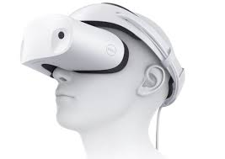

Figure 9 VR Display (HMDs)

1. **VR Interaction (VR Controllers):** VR interaction refers to how users engage with the virtual environment. This often involves VR controllers, which enable users to manipulate objects and navigate within the virtual space.

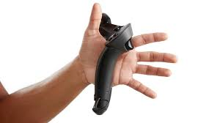

Figure 10 VR controller.

1. **VR Content:** VR content encompasses the digital elements displayed within the virtual environment. This includes 3D graphics, animations, and simulations that immerse users in the virtual world.

By considering these three components, developers can design VR applications that leverage the strengths of each aspect while addressing potential limitations. For example, when designing a VR ping pong application, developers must ensure:

* The VR display supports position tracking to allow natural body movement.
* VR controllers accurately track the position and orientation of the ping pong bat, with haptic feedback to enhance realism.
* VR content includes realistic 3D graphics and animations, simulating the physics of the ping pong ball's motion.

However, when designing a VR shopping application for trying on clothes, **challenges arise:**

* Realistic texture feedback through VR interaction may exceed current VR hardware capabilities.
* The limitations of existing VR hardware, such as wired connections and spatial constraints, may impact the feasibility of certain interactions, such as moving freely to explore virtual environments.

## 360 Video and Model Based VR

In digital content, there are **two primary types**: video content and computer-generated 3D content.

|  |  |
| --- | --- |
| **Video Content** | * Typically shot in the real world with cameras, capturing real people and environments. * Most news, TV series, and movies fall into this category, either entirely or in combination with computer-generated content. * Provides highly realistic visuals but is limited to what is captured during filming. |
| **Computer-Generated 3D Content (CGI)** | * Also known as computer-generated imagery (CGI), it can simulate photorealistic real-world images or create fantastical worlds with imaginative creatures. * Often used in animated films by studios like Pixar. * Requires creating and animating 3D models, which are then captured with virtual cameras. * Offers flexibility as creators can manipulate and reuse 3D models and animations. |
| **Usage** | * In video content, everything is captured from real life using cameras and stored as images or pixels, resulting in highly realistic visuals. * Computer-generated content involves creating and animating 3D models, offering flexibility and the ability to interact with virtual environments in real-time. * 3D computer games utilize computer-generated 3D models, allowing users to freely navigate and interact with objects. * VR content is based on 3D models stored with mathematical descriptions of geometry and materials, enabling users to control virtual cameras and view the environment from any angle. * Model-based VR is best experienced with high-end VR displays that offer both rotation and position tracking, allowing users to move closer to objects and explore the virtual environment more intuitively. |

**Useful links:**

Volumetric capturing: <https://youtu.be/kZ-XZIV-o8s>

Photogrammetry

* <http://www.theastronauts.com/2014/03/visual-revolution-vanishing-ethan-carter/>